Pizza Sales Analysis — Summary Report
Name: Bhatti Prabhpreet Singh
Tools: SQL (data querying & KPIs), Excel (pivot tables & dashboard)
Dataset: pizza_sales — 48,620+ line-item records of individual pizza orders
1. Executive Summary
This project analyzes a full year of pizza sales to understand overall business performance, customer ordering behaviors, and product popularity. Using SQL to calculate key metrics and Excel to visualize trends, the analysis surfaces clear opportunities to increase revenue through menu optimization, staffing alignment, and targeted promotions.
Headline results:
KPI | Value
Total Revenue | $817,860
Total Orders | 21,350
Total Pizzas Sold | 49,574
Average Order Value | $38.31
Average Pizzas per Order | 2.32

2. Objectives
The analysis set out to answer five core business questions:
- How is the business performing overall (revenue, orders, volume)?
- When are customers ordering by day of week and by hour?
- Which pizza categories and sizes drive the most revenue?
- What are the best-selling and worst-selling pizzas?
- Where are the biggest opportunities to grow revenue?

3. Methodology
- Data extraction & KPIs: Wrote SQL queries against the pizza_sales table to calculate revenue, order counts, volume, and trend breakdowns (daily, hourly, by category, by size).
- Aggregation: Grouped data by time dimensions and product attributes to identify patterns.
- Visualization: Built pivot tables and an interactive dashboard in Excel to present the findings visually.

4. Key Findings & Insights

4.1 Sales by Day of Week
Day | Orders (relative)
Friday (highest) | 2,462
Saturday | 2,170
Thursday | 2,103
Monday | 2,059
Wednesday | 2,012
Tuesday | 1,962
Sunday (lowest) | 1,803
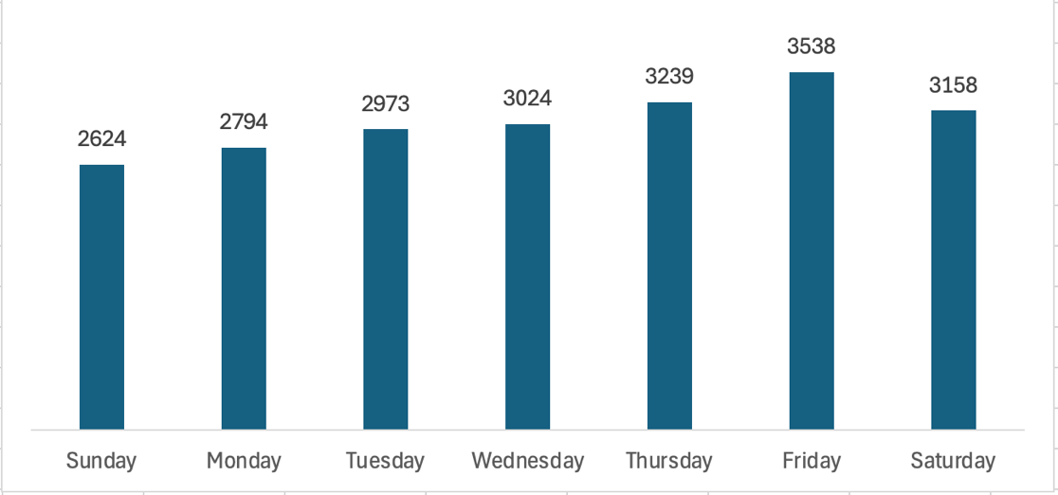

Insight: Orders increase toward the end of the week, with Friday recording the highest volume (2,462 orders). Thursday through Saturday form the strongest sales period, while Sunday has the lowest order volume (1,803 orders). This indicates customer demand is highest leading into the weekend, suggesting opportunities for targeted promotions and staffing optimization during peak periods.

4.2 Sales by Hour of Day
Time | Orders (relative)
12 pm | 1,687
1 pm | 1,641
6 pm | 1,643
5 pm | 1,611
4 pm | 1,314
7 pm | 1,365
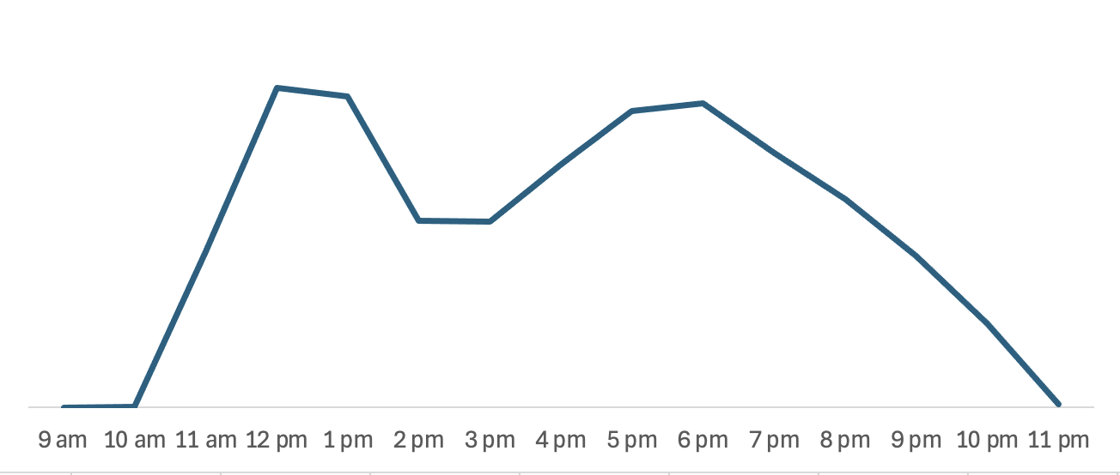

Insight: Pizza sales are highest during lunch (12-1 PM) and dinner (5-7 PM), with these two periods generating most of the daily orders. Demand remains low during the early morning and late evening hours, highlighting the importance of staffing and inventory planning around peak mealtimes.

4.3 Revenue by Pizza Category
Category | % of Revenue
Classic | 26.9%
Supreme | 25.5%
Veggie | 23.9%
Chicken | 23.7%

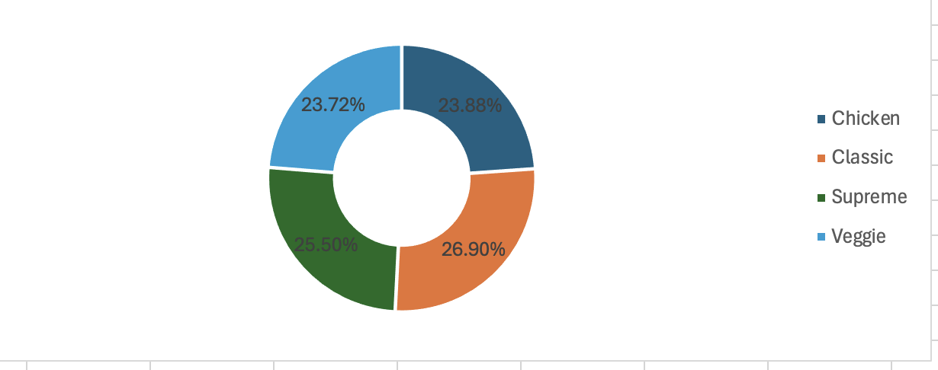

Insight: Revenue is well distributed across all four pizza categories, with the Classic category generating the highest sales. The relatively balanced revenue contribution suggests that customers enjoy a diverse range of products rather than relying heavily on a single category. This broad appeal helps create a more stable revenue stream and reduces dependence on any one product line.

4.4 Revenue by Pizza Size
Size | % of Revenue
Large | 45.7%
Medium | 30.7%
Regular (Small) | 21.7%
X-Large | 1.8%
XX-Large | 0.1%

Insight: Large pizzas are the strongest revenue-generating size, contributing nearly half of total sales. Combined with Medium pizzas, these sizes account for more than 76% of overall revenue, highlighting strong customer preference for mid-to-large portions. Meanwhile, X-Large and XX-Large pizzas have minimal revenue contribution and may warrant further evaluation to determine their strategic value on the menu.

4.5 Pizzas Sold by Category (Volume)
Category | Pizzas Sold
Classic | 10,061
Supreme | 8,129
Veggie | 7,958
Chicken | 7,452

Insight: Classic pizzas are the top-performing category, generating the highest revenue and sales volume. Their strong and consistent demand indicates they are a customer favorite and a major contributor to the business's overall success.

4.6 Top 5 Best-Selling Pizzas
Rank | Pizza | Quantity Sold
1 | The Barbecue Chicken Pizza | 1,675
2 | The Pepperoni Pizza | 1,642
3 | The Classic Deluxe Pizza | 1,633
4 | The California Chicken Pizza | 1,615
5 | The Hawaiian Pizza | 1,602

4.7 Bottom 5 Worst-Selling Pizzas
Rank | Pizza | Quantity Sold
1 | The Brie Carre Pizza | 330
2 | The Mediterranean Pizza | 621
3 | The Calabrese Pizza | 631
4 | The Spinach Pesto Pizza | 652
5 | The Chicken Pesto Pizza | 653

Insight: Customer demand is concentrated around familiar and popular flavors such as BBQ Chicken, Pepperoni, and Hawaiian, which consistently rank among the top sellers. Specialty pizzas, particularly The Brie Carre Pizza, show significantly lower demand, with only 330 units sold. This difference highlights a clear preference for traditional menu items and may indicate an opportunity to reassess the positioning, pricing, or promotion of lower-performing specialty pizzas.

5. Recommendations
Based on the findings, I recommend the following actions:
- Align staffing to demand peaks. Schedule maximum staff for the lunch (12–1 pm) and dinner (5–7 pm) rushes, and on Thursday–Saturday, to reduce wait times and capture peak revenue.
- Boost slow periods with promotions. Introduce Sunday deals or early-week ("Tuesday two-for-one") offers to lift the quietest days.
- Upsell Large pizzas. Since Large drives ~46% of revenue, train staff to upsell to Large and create value bundles. Investigate why X-Large/XX-Large barely sell, consider repricing, better menu placement, or removing them.
- Feature best-sellers & re-evaluate underperformers. Promote the top 5 in combos and featured spots. Review the Brie Carre and other bottom performers, either reposition/market them or consider retiring them to streamline operations.
- Protect the Classic category. As the top performer in both revenue and volume, keep Classic pizzas prominent and well-stocked.

6. Conclusion
The pizzeria generated $817,860 in revenue across 21,350 orders in 2015, with a healthy average order value of $38.31. The business is weekend- and rush-hour driven, powered by Large pizzas and a balanced, broadly appealing menu led by Classic varieties. The clearest growth levers are demand-aligned staffing, promotions during slow periods, upselling larger sizes, and rationalizing underperforming menu items.

